1.1P: Preparing for OOP – Answer Sheet

1. Explain the following terminal instructions:
   1. cd: Change Directory
   2. ls: List Files
   3. pwd: Print Directory

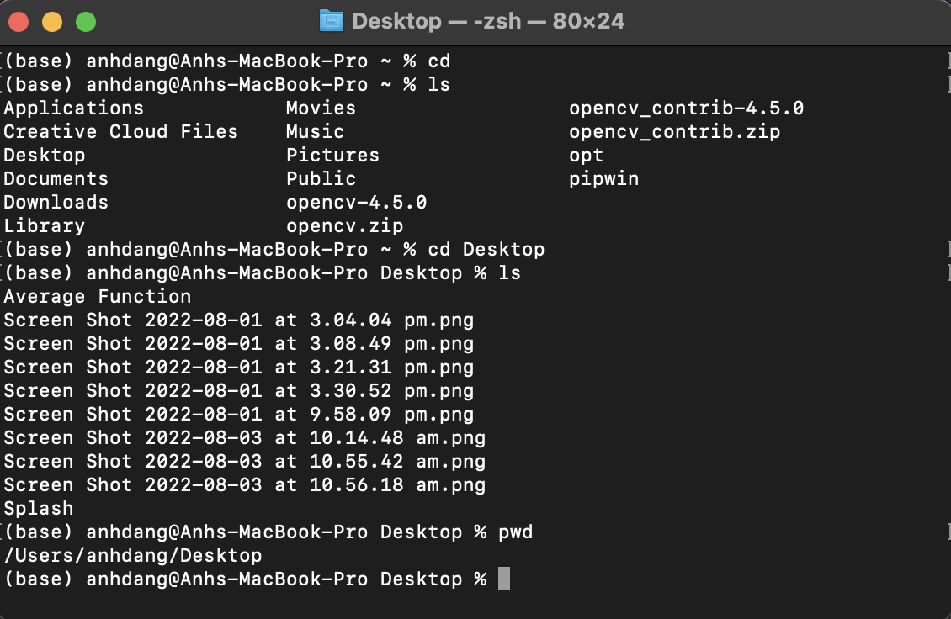

1. Consider the following kinds of information, and suggest the most appropriate data type to store or represent each:

|  |  |
| --- | --- |
| Information | Suggested Data Type |
| A person’s name | String |
| A person’s age in years | Integer |
| A phone number | String or Integer |
| A temperature in Celsius | Float |
| The average age of a group of people | Integer |
| Whether a person has eaten lunch | Boolean |

1. Aside from the examples already provided in question 2, come up with an example of information that could be stored as:

|  |  |
| --- | --- |
| Data type | Suggested Information |
| String | Product name |
| Integer | Number of products |
| Float | Distance |
| Boolean | Is 2 an integer? |

1. Fill out the following table, evaluating the value of each expression and identifying the data type the value is most likely to be:

|  |  |  |  |
| --- | --- | --- | --- |
| Expression | Given | Value | Data Type |
| 6 |  | 6 | Integer |
| True |  | True | Boolean |
| a | a = 2.5 | 2.5 | Integer |
| 1 + 2 * 3 |  | 7 | Integer |
| a and False | a = True | True | Boolean |
| a or False | a = True | True | Boolean |
| a + b | a = 1  b = 2 | 3 | Integer |
| 2 * a | a = 3 | 6 | Integer |
| a * 2 + b | a = 2.5 b = 2 | 7.0 | Integer |
| a + 2 * b | a = 2.5  b = 2 | 6.5 | Float |
| (a + b) * c | a = 1  b = 1  c = 5 | 10 | Integer |
| “Fred” + “ Smith” |  | Fred Smith | String |
| a + “ Smith” | a = “Wilma” | Wilma Smith | String |

1. Using an example, explain the difference between **declaring** and **initialising** a variable.

D**eclaring** is used to specify the type of data for the variable. While **initializing** is used to set the value to its initial and it must be compatible to use in the **declaring** type of data.

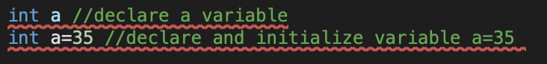

1. Explain the term **parameter**. Write some code that demonstrates a simple of use of a parameter. You should show a procedure or function that uses a parameter, and how you would call that procedure or function.

A parameter is a variables inside the method and it will be becoming an argument after passing to the method.

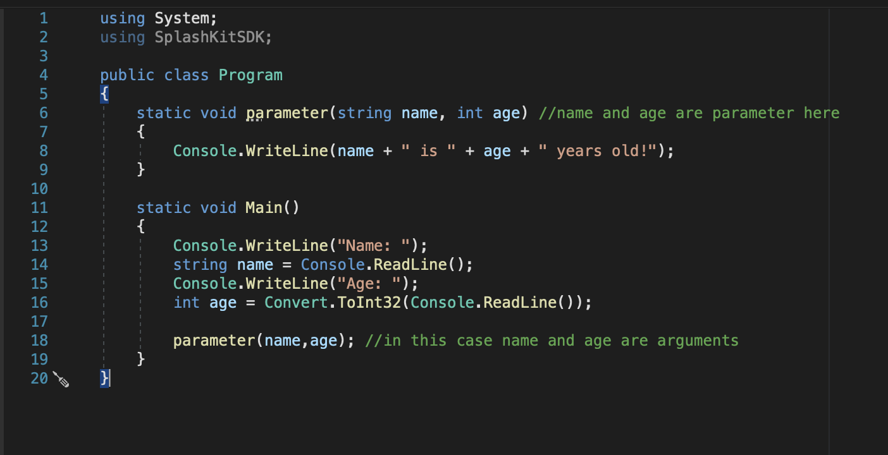

1. Using an example, describe the term **scope**.

Scope is where variables can be accessed or referenced.

For example:

Local Scope:

def print_local_number()

x = 10

print(x)

print_local_number() #Calling this function will print its local variable in the function

as if you try to print it globally it will show an error in the terminal command

def print_local_number()

x = 10

print(x) #This will show an error

Global Scope:

x = 10 #Set this as global variable

def multiply()

x = x * 5

print(x)

multiply() #Variable x can be use globally in any function.

1. In any procedural language you like, write a function called Average, which accepts an array of integers and returns the average of those integers. Do not use any libraries for calculating the average. You must demonstrate appropriate use of parameters, returning and assigning values, and use of a loop. Note — just write the function at this point, we’ll *use* it in the next task. You shouldn’t have a complete program or even code that outputs anything yet at the end of this question.

Python:

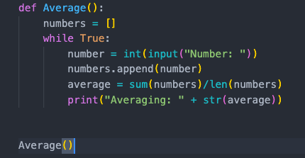

C#:

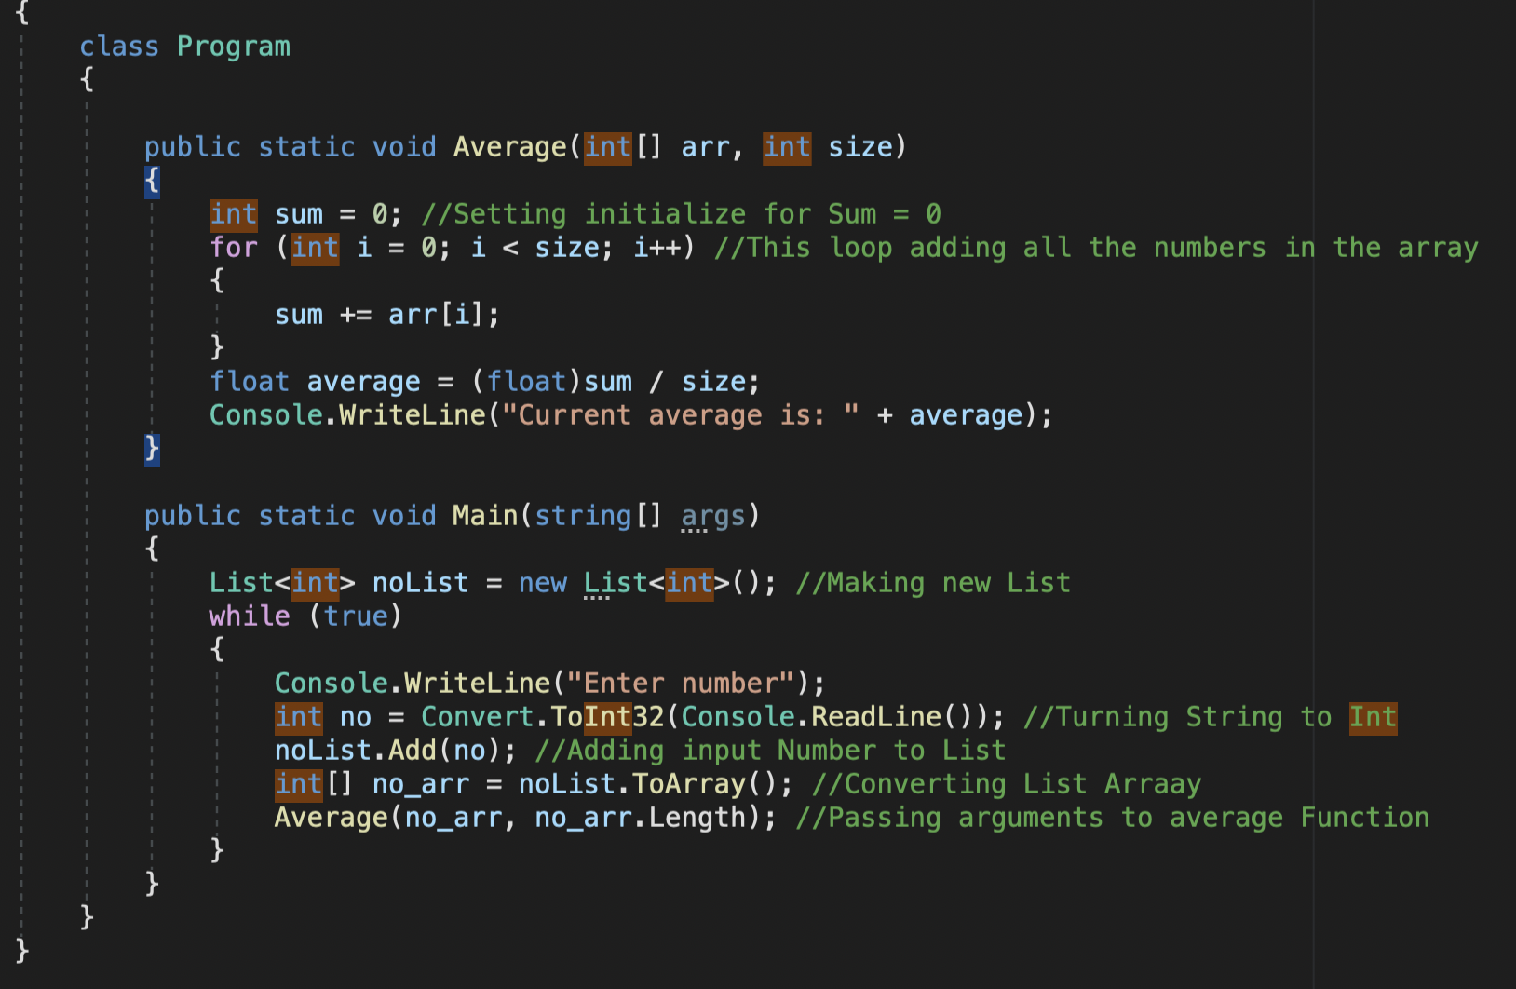

1. In the same language, write the code you would need to call that function and print out the result.

*These has been done in the previous question (question 8)*

1. To the code from 9, add code to print the message “Double digits” if the average is above or equal to 10. Otherwise, print the message “Single digits”. Provide a screenshot of your program running.

*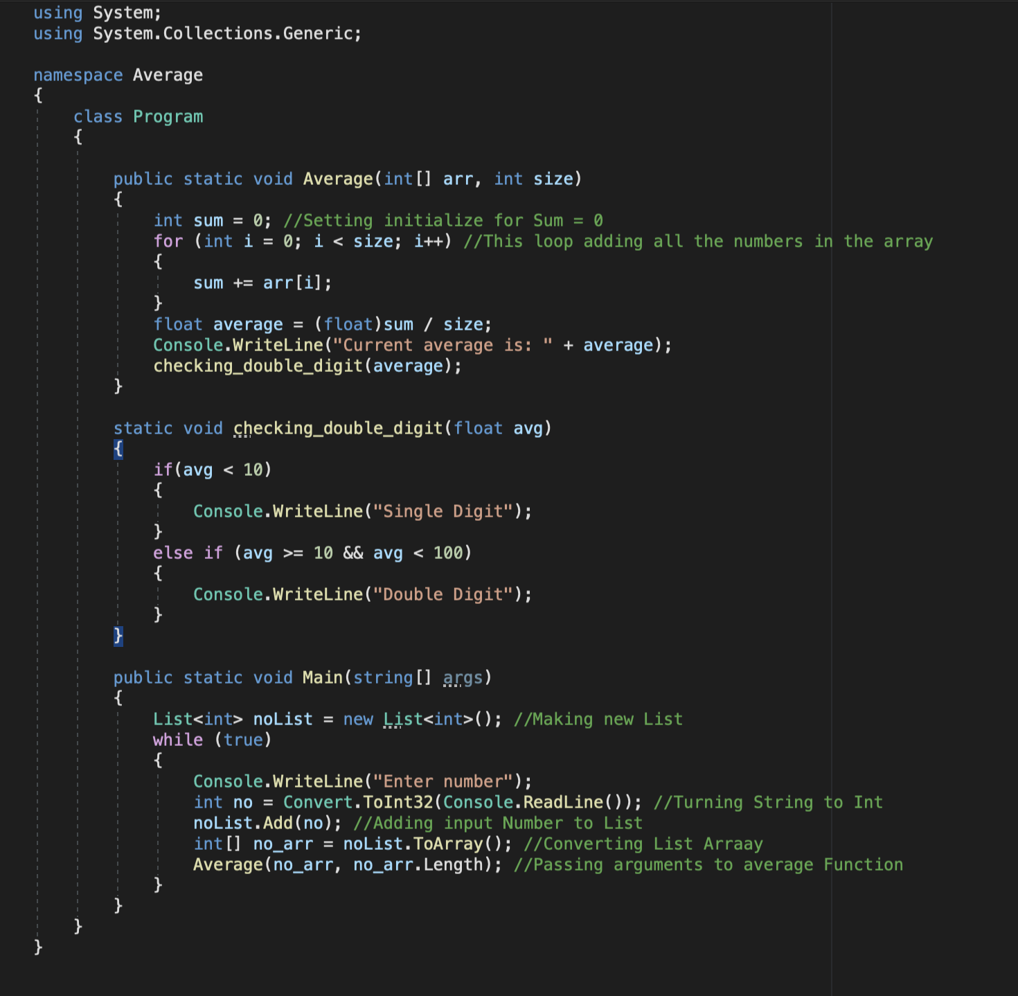  
  
<insert a screenshot of your whole program running here>*

